TASK APP
Week 7 / 8
Kubernetes + Full App (Frontend + Backend)

Note:
At this stage, we are moving from a simple containerized application to a more realistic production-ready structure.
Previously, our application was packaged into a single Docker image, mainly focusing on the backend (API). While this works for learning and small setups, it is not how modern applications are built or deployed in real-world environments. So I will suggest you separate your Frontend & Backend files in two different folder so that we can build docker images separately from both.
- Frontend: Handles user interface (HTML, CSS, JavaScript)

- Backend: Handles App logic and APIs

Build Docker Image- Frontend & Backend(Ensure your Docker is running)

- Create a Docker file inside Frotend & Backend folder (delete the old docker file)
- Copy the Docker build code for each inside the corresponding file.
- Build Backend image: From the main project folder run: docker build -t [your-docker-username]/[your-Docker-repo-name-backend]:latest ./backend
- Build Frontend Image: docker build -t [your-docker-username]/[your-Docker-repo-name-frontend]:latest ./frontend
- Verify Images: docker images
- Push to Docker Hub: Push both images to docker hub
docker push [backed]
docker push [frontend]
Note: copy the images and replace accordingly.
Kubernetes
Docs read more https://kubernetes.io/docs/concepts/overview/

Introduction to Kubernetes
Kubernetes is a system used to run and manage containerized applications automatically. Instead of manually starting containers, restarting them when they fail, and figuring out how they communicate, Kubernetes takes over these responsibilities and ensures the application is always running as expected.

In our current setup, we have a frontend and a backend running as separate containers. When using Docker alone, we are responsible for starting these containers, keeping them running, and making sure they can talk to each other. If the backend crashes or the system needs to handle more users, we have to manage that manually. This approach works for small setups but becomes difficult to maintain as the application grows.

Kubernetes solves this by introducing a structured way to define how the application should run. Instead of running containers directly, we describe the desired state of the system, such as “one backend should always be running” or “the frontend should be accessible from the browser.” Kubernetes continuously ensures that this state is maintained. If a container stops, it is restarted automatically. If more capacity is needed, additional instances can be created.

Another important role Kubernetes plays is managing communication between services. In our application, the frontend needs to send requests to the backend. With Docker alone, this often depends on fixed ports or manual configuration. Kubernetes replaces this with internal services, allowing components to communicate using stable names like backend-service, regardless of where the containers are actually running.

In summary, Kubernetes shifts the responsibility of managing containers from the developer to the system. Instead of focusing on how to run and maintain containers, we focus on defining what we want the application to look like, and Kubernetes ensures it stays in that state.

Steps
- Install Kubernetes (K3s on VM)
Install: curl -sfL https://get.k3s.io | sh -
Verify: sudo kubectl get nodes
Expanation:
You install K3s on the same VM where Jenkins is running. This is important because it keeps your pipeline and runtime environment together.
Your VM is no longer just a server running containers manually. It becomes a Kubernetes node capable of running managed workloads.

- Backend Deployment
- Create a folder in your project root folder: mkdir k8s
- Create a backend-deployment.yaml file inside the folder,
Then copy the updated yaml code and also make sure your correct image link is replace inside the yaml file.
- Make your repository available on your VM. You can do this by cloning your repository: git clone https://github.com/YOUR_USERNAME/YOUR_REPO.git
Then cd to your cloned repo
This step is required because Kubernetes will read the YAML file from the VM.

- Apply: Locate your kubernetes folder (k8s) inside your VM and run:
Sudo kubectl apply -f backend-deployment.yaml
This command sends the configuration file to Kubernetes and tells it to create the backend based on the instructions in the file.
Verify: sudo kubectl get pods

Explanation: The yaml file contains the instructions of how your backend should run in Kubernetes.
Instead of manually starting a container, you are declaring:
Which image to use (task-app-backend) from docker hub
How many instances should run (replicas: 1 (you can have more.)
What port the application uses (3000)
Kubernetes reads this file and ensures that this backend is always running.

It runs and creates a Pod.
Note:
A Pod is the unit in which your application runs in Kubernetes, containing your container and managed automatically by the system.
- Docker: runs containers
- Kubernetes: runs Pods (which contain containers)

- Create a Service.
Creating a service will:

• Give your backend a stable internal name
• Allow your frontend to connect to it
• Enable communication inside Kubernetes

Steps:

- Create backend-service.yaml in your local folder insiide the k8s folder.
Copy the code into the folder and push to github
- Pull from github to your VM. Make it available on your VM
- Confirm that the file now exist in your VM then apply: sudo kubectl apply -f backend-service.yaml
- Verify: sudo kubectl get svc

You should see your backend service listed, along with:
- A ClusterIP (internal IP)
- The port (3000)

- Frontend Deployment
- Create the yaml file for both deploment and service file Inside k8s folder in your local project: frontend-deployment.yaml , frontend-service.yaml. Copy the config code accordingly. Don’t forget to update image name also
- Push to guthub and pull to your VM
- Go to your K8s folder and run: sudo kubectl apply -f frontend-deployment.yaml and sudo kubectl apply -f frontend-service.yaml
- Verify they exist: sudo kubectl get pods and sudo kubectl get svc
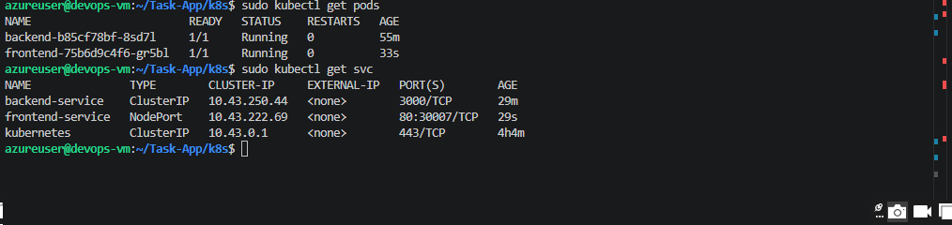

- Verifycurl in your VM: curl http://localhost:30007 if you get an html code it means
Kubernetes is working
Frontend is working

- Add Rule for Kubernetes in your provider:
- Allow in bound rule:
- Also Update the secutity rule in your main.tf and run: terraform apply
Port: 30007
Protocol: TCP
Access: Allow
Direction: Inbound

- Test in browser: http://YOUR-VM-IP:30007 or make sure this port is the same as the front-end service in kubernestes

Kubernetes Implementation Summary
In this stage, we deployed our application (frontend and backend) into Kubernetes and connected all components together.
First, we created a Deployment for the backend. This allowed Kubernetes to run the backend container using the Docker image and ensure it is always running. Instead of manually starting containers, Kubernetes now manages the lifecycle of the backend.
Next, we created a Service for the backend. This gave the backend a stable internal name (backend-service) so other components, like the frontend, can reliably communicate with it. This solves the problem of changing Pod IP addresses.
We then repeated the same process for the frontend by creating a Deployment, which runs the UI inside Kubernetes, and a Service of type NodePort, which exposes the application to the outside world through the VM’s IP address and a specific port.
After configuring both services, we updated the frontend to communicate with the backend using the Kubernetes service name instead of localhost. This allows proper communication within the cluster.

Jenkins -> Kubernetes Integration
When we Push → Jenkins builds image → Jenkins pushes to Docker Hub → Jenkins updates Kubernetes

What Happens Step-by-Step
- You push code to GitHub
- Jenkins runs pipeline
- Jenkins builds new image
- Jenkins pushes image to Docker Hub
- Jenkins tells Kubernetes to use that image
- Kubernetes pulls the updated image
- Kubernetes replaces old Pods

Update your jenkinsfile: copy the updated code from github and make sure you configure your image build in the file correctly.

The jenkins file is now updated to build both services, pushes them to Docker Hub, and automatically updates your running Kubernetes application.

Push
git add .
git commit -m "add k8s deploy stage"
git push

